Detection of Cyberbullying on Social Media Using Machine learning
ABSTRACT:
Cyberbullying is a major problem encountered on internet that affects teenagers and also adults. It has lead to mishappenings like suicide and depression. Regulation of content on Social media platorms has become a growing need. The following study uses data from two different forms of cyberbullying, hate speech tweets from Twittter and comments based on personal attacks from Wikipedia forums to build a model based on detection of Cyberbullying in text data using Natural Language Processing and Machine learning. Three methods for Feature extraction and four classifiers are studied to outline the best approach. For Tweet data the model provides accuracies above 90% and for Wikipedia data it gives accuracies above 80%.

  - MODULE DESCRIPTION

IMPLEMENTATION
MODULES:
- Data Collection
- Dataset
- Data Preparation
- Model Selection
- Analyze and Prediction
- Accuracy on test set
- Saving the Trained Model

MODULES DESCSRIPTION

Twitter Hate detection
Data Collection:
This is the first real step towards the real development of a machine learning model, collecting data. This is a critical step that will cascade in how good the model will be, the more and better data that we get, the better our model will perform. There are several techniques to collect the data, like web scraping, manual interventions and etc.Detection of Cyberbullying on Social Media Using Machine learning We given the Twitter Hate data set in the project folder

Dataset:
The dataset consists of 31962 individual data. There are 3 columns in the dataset, which are described below
- Id: unique id
- Labels :
1: offensive
0: non offensive
- Tweet : comment

Data Preparation:
We will transform the data. by getting rid of missing data and removing some columns. First we will create a list of column names that we want to keep or retain.
Next we drop or remove all columns except for the columns that we want to retain.
Finally we drop or remove the rows that have missing values from the data set.
Steps to follow:
- Removing extra symbols
- Removing punctuations
- Removing the Stopwords
- Stemming
- Tokenization
- Feature extractions
- TF-IDF vectorizer
- Counter vectorizer with TF-IDF transformer
Model Selection:
We used SVC algorithms

Support Vector Machine algorithm:
SVM offers very high accuracy compared to other classifiers such as logistic regression, and decision trees. It is known for its kernel trick to handle nonlinear input spaces. It is used in a variety of applications such as face detection, intrusion detection, classification of emails, news articles and web pages, classification of genes, and handwriting recognition.
In this tutorial, you will be using scikit-learn in Python. If you would like to learn more about this Python package, I recommend you take a look at our Supervised Learning with scikit-learn course.
SVM is an exciting algorithm and the concepts are relatively simple. The classifier separates data points using a hyperplane with the largest amount of margin. That's why an SVM classifier is also known as a discriminative classifier. SVM finds an optimal hyperplane which helps in classifying new data points.

Support Vector Machines
Generally, Support Vector Machines is considered to be a classification approach, it but can be employed in both types of classification and regression problems. It can easily handle multiple continuous and categorical variables. SVM constructs a hyperplane in multidimensional space to separate different classes. SVM generates optimal hyperplane in an iterative manner, which is used to minimize an error. The core idea of SVM is to find a maximum marginal hyperplane(MMH) that best divides the dataset into classes.
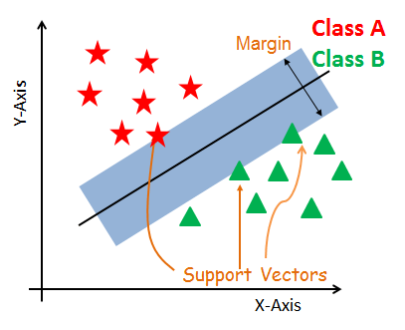
Support Vectors
Support vectors are the data points, which are closest to the hyperplane. These points will define the separating line better by calculating margins. These points are more relevant to the construction of the classifier.
Hyperplane
A hyperplane is a decision plane which separates between a set of objects having different class memberships.
Margin
A margin is a gap between the two lines on the closest class points. This is calculated as the perpendicular distance from the line to support vectors or closest points. If the margin is larger in between the classes, then it is considered a good margin, a smaller margin is a bad margin.
How does SVM work?
The main objective is to segregate the given dataset in the best possible way. The distance between the either nearest points is known as the margin. The objective is to select a hyperplane with the maximum possible margin between support vectors in the given dataset. SVM searches for the maximum marginal hyperplane in the following steps:
Generate hyperplanes which segregates the classes in the best way. Left-hand side figure showing three hyperplanes black, blue and orange. Here, the blue and orange have higher classification error, but the black is separating the two classes correctly.
Select the right hyperplane with the maximum segregation from the either nearest data points as shown in the right-hand side figure.
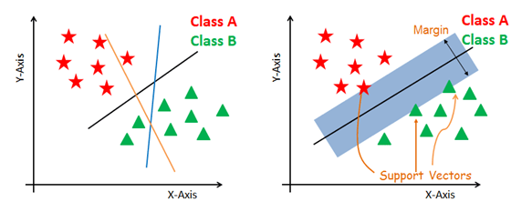
Dealing with non-linear and inseparable planes
Some problems can’t be solved using linear hyperplane, as shown in the figure below (left-hand side).
In such situation, SVM uses a kernel trick to transform the input space to a higher dimensional space as shown on the right. The data points are plotted on the x-axis and z-axis (Z is the squared sum of both x and y: z=x^2=y^2). Now you can easily segregate these points using linear separation.
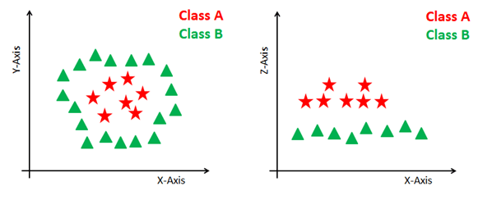
SVM Kernels
The SVM algorithm is implemented in practice using a kernel. A kernel transforms an input data space into the required form. SVM uses a technique called the kernel trick. Here, the kernel takes a low-dimensional input space and transforms it into a higher dimensional space. In other words, you can say that it converts nonseparable problem to separable problems by adding more dimension to it. It is most useful in non-linear separation problem. Kernel trick helps you to build a more accurate classifier.
Linear Kernel A linear kernel can be used as normal dot product any two given observations. The product between two vectors is the sum of the multiplication of each pair of input values.
K(x, xi) = sum(x * xi)
Polynomial Kernel A polynomial kernel is a more generalized form of the linear kernel. The polynomial kernel can distinguish curved or nonlinear input space.
K(x,xi) = 1 + sum(x * xi)^d
Where d is the degree of the polynomial. d=1 is similar to the linear transformation. The degree needs to be manually specified in the learning algorithm.
Radial Basis Function Kernel The Radial basis function kernel is a popular kernel function commonly used in support vector machine classification. RBF can map an input space in infinite dimensional space.
K(x,xi) = exp(-gamma * sum((x – xi^2))
Here gamma is a parameter, which ranges from 0 to 1. A higher value of gamma will perfectly fit the training dataset, which causes over-fitting. Gamma=0.1 is considered to be a good default value. The value of gamma needs to be manually specified in the learning algorithm.

Analyze and Prediction:
In the actual dataset, we chose only 2 features :

- Text: the tweets
2 Labels :
1: offensive
0: non offensive

Accuracy on test set:
We got an accuracy of 96.02% on test set.

Saving the Trained Model:

Once you’re confident enough to take your trained and tested model into the production-ready environment, the first step is to save it into a .h5 or . pkl file using a library like pickle .
Make sure you have pickle installed in your environment.
Next, let’s import the module and dump the model into . pkl file

Wikipedia attack
Data Collection:
This is the first real step towards the real development of a machine learning model, collecting data. This is a critical step that will cascade in how good the model will be, the more and better data that we get, the better our model will perform.
There are several techniques to collect the data, like web scraping, manual interventions and etc.
Detection of Cyberbullying on Social Media Using Machine learning

We given the wikipedia attack data set in the project folder

Dataset:
The dataset consists of 115864 individual data. There are 4 columns in the dataset, which are described below
- Review Id: unique id
- comment : comment about wikipedia titles
- year : year of comment
- attack : Personal attack or non personal attack

Data Preparation:
We will transform the data. by getting rid of missing data and removing some columns. First we will create a list of column names that we want to keep or retain.
Next we drop or remove all columns except for the columns that we want to retain.
Finally we drop or remove the rows that have missing values from the data set.
Steps to follow:
- Removing extra symbols
- Removing punctuations
- Removing the Stopwords
- Stemming
- Tokenization
- Feature extractions
- TF-IDF vectorize
- Counter vectorizer with TF-IDF transformer

Model Selection:
We used Random Forest Classifier algorithms
Random Forests Classifiers:
Random forests is a supervised learning algorithm. It can be used both for classification and regression. It is also the most flexible and easy to use algorithm. A forest is comprised of trees. It is said that the more trees it has, the more robust a forest is. Random forests creates decision trees on randomly selected data samples, gets prediction from each tree and selects the best solution by means of voting. It also provides a pretty good indicator of the feature importance.
The Random Forests Algorithm
Let’s understand the algorithm in layman’s terms. Suppose you want to go on a trip and you would like to travel to a place which you will enjoy.
So what do you do to find a place that you will like? You can search online, read reviews on travel blogs and portals, or you can also ask your friends.
Let’s suppose you have decided to ask your friends, and talked with them about their past travel experience to various places. You will get some recommendations from every friend. Now you have to make a list of those recommended places. Then, you ask them to vote (or select one best place for the trip) from the list of recommended places you made. The place with the highest number of votes will be your final choice for the trip.
In the above decision process, there are two parts. First, asking your friends about their individual travel experience and getting one recommendation out of multiple places they have visited. This part is like using the decision tree algorithm. Here, each friend makes a selection of the places he or she has visited so far.
The second part, after collecting all the recommendations, is the voting procedure for selecting the best place in the list of recommendations. This whole process of getting recommendations from friends and voting on them to find the best place is known as the random forests algorithm.
It technically is an ensemble method (based on the divide-and-conquer approach) of decision trees generated on a randomly split dataset. This collection of decision tree classifiers is also known as the forest. The individual decision trees are generated using an attribute selection indicator such as information gain, gain ratio, and Gini index for each attribute. Each tree depends on an independent random sample. In a classification problem, each tree votes and the most popular class is chosen as the final result. In the case of regression, the average of all the tree outputs is considered as the final result. It is simpler and more powerful compared to the other non-linear classification algorithms.
How does the algorithm work?
It works in four steps:
Select random samples from a given dataset.
Construct a decision tree for each sample and get a prediction result from each decision tree.
Perform a vote for each predicted result.
Select the prediction result with the most votes as the final prediction.
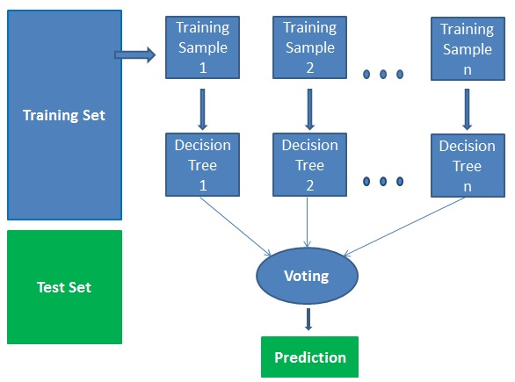
Advantages:
Random forests is considered as a highly accurate and robust method because of the number of decision trees participating in the process.
It does not suffer from the overfitting problem. The main reason is that it takes the average of all the predictions, which cancels out the biases.
The algorithm can be used in both classification and regression problems.
Random forests can also handle missing values. There are two ways to handle these: using median values to replace continuous variables, and computing the proximity-weighted average of missing values.
You can get the relative feature importance, which helps in selecting the most contributing features for the classifier.
Disadvantages:
Random forests is slow in generating predictions because it has multiple decision trees. Whenever it makes a prediction, all the trees in the forest have to make a prediction for the same given input and then perform voting on it. This whole process is time-consuming.
The model is difficult to interpret compared to a decision tree, where you can easily make a decision by following the path in the tree.
Finding important features
Random forests also offers a good feature selection indicator. Scikit-learn provides an extra variable with the model, which shows the relative importance or contribution of each feature in the prediction. It automatically computes the relevance score of each feature in the training phase. Then it scales the relevance down so that the sum of all scores is 1.
This score will help you choose the most important features and drop the least important ones for model building.
Random forest uses gini importance or mean decrease in impurity (MDI) to calculate the importance of each feature. Gini importance is also known as the total decrease in node impurity. This is how much the model fit or accuracy decreases when you drop a variable. The larger the decrease, the more significant the variable is. Here, the mean decrease is a significant parameter for variable selection. The Gini index can describe the overall explanatory power of the variables.
Random Forests vs Decision Trees
Random forests is a set of multiple decision trees.
Deep decision trees may suffer from overfitting, but random forests prevents overfitting by creating trees on random subsets.
Decision trees are computationally faster.
Random forests is difficult to interpret, while a decision tree is easily interpretable and can be converted to rules.
Analyze and Prediction:
In the actual dataset, we chose only 2 features :

1 Text: the tweets
2 Labels :
1: personal attack
0: non personal attack
Accuracy on test set:
We got a accuracy of 99.02% on test set.

Saving the Trained Model:

Once you’re confident enough to take your trained and tested model into the production-ready environment, the first step is to save it into a .h5 or . pkl file using a library like pickle .
Make sure you have pickle installed in your environment.
Next, let’s import the module and dump the model into . pkl file

PROBLEM IDENTIFICATION

1. Background of the Problem
Social media platforms such as Facebook, Instagram, Twitter (X), YouTube, and online forums have become an integral part of daily communication. While these platforms enable users to express opinions, share information, and connect globally, they have also given rise to a serious social issue known as cyberbullying.
Cyberbullying refers to the act of harassing, threatening, humiliating, or targeting individuals using digital platforms. Unlike traditional bullying, cyberbullying occurs 24/7, spreads rapidly, and can reach a large audience instantly. The anonymity provided by social media further encourages aggressive and abusive behavior.
Despite increasing awareness, cyberbullying remains difficult to detect and control due to the massive volume of user-generated content posted every second.

2. Definition of the Problem
The core problem is the lack of efficient, accurate, and automated systems to identify and detect cyberbullying content on social media platforms in real time.
Currently, most platforms rely on:
- Manual content moderation
- User reports
- Basic keyword filtering
These methods are slow, inconsistent, and ineffective for handling large-scale data. As a result, harmful content often remains online for long periods, causing psychological and emotional harm to victims.

3. Why Cyberbullying Detection is Challenging
Cyberbullying detection is a complex problem due to several factors:

3.1 Massive Data Volume
Millions of posts, comments, images, and messages are generated daily on social media. Manual monitoring of such data is practically impossible.

3.2 Language Variations
Cyberbullying content may appear in:
- Slang
- Abbreviations
- Emojis
- Multiple languages
- Code-mixed text (e.g., English + Tamil)
This makes traditional rule-based systems ineffective.

3.3 Contextual Understanding
Not all offensive words indicate cyberbullying. The context in which words are used determines whether content is harmful, sarcastic, or harmless. Human-like understanding is required to interpret intent.

3.4 Evolving Bullying Patterns
Cyberbullies constantly invent new words, phrases, and tactics to bypass content filters, making static detection systems outdated quickly.

4. Limitations of Existing Systems
Current cyberbullying detection approaches suffer from several limitations:
- High false positives (normal content flagged as bullying)
- High false negatives (bullying content not detected)
- Dependency on manual reporting
- Inability to analyze sentiment and intent effectively
- Poor performance on multilingual and informal text
These limitations highlight the need for a more intelligent and adaptive solution.

5. Impact of the Problem
The consequences of cyberbullying are severe and long-lasting:

5.1 Psychological Impact
Victims may experience:
- Depression
- Anxiety
- Low self-esteem
- Social isolation
- Suicidal thoughts

5.2 Social Impact
Cyberbullying affects:
- School and college environments
- Workplace productivity
- Online community trust

5.3 Legal and Ethical Concerns
Failure to detect and prevent cyberbullying can result in:
- Legal issues for social media platforms
- Ethical responsibility failures
- Violation of digital safety norms

6. Need for Machine Learning-Based Solution
Machine Learning (ML) provides the ability to:
- Automatically learn patterns from large datasets
- Adapt to new bullying trends
- Analyze text context and sentiment
- Process data at scale and speed
Unlike rule-based systems, ML models improve their accuracy over time through training and optimization.

7. Problem Statement
There is a critical need for an intelligent, automated, and scalable system that can accurately detect cyberbullying content on social media platforms using machine learning techniques, in order to protect users from psychological harm and promote a safer online environment.

- SYSTEM STUDY AND ANALYSIS

SYSTEM STUDY
Analysis is a detailed study of various operations performed by a system and their relationships within and outside the system. One aspect of analysis is defining the boundaries of the system and determining whether a candidate system should consider other related systems. During analysis data is collected on the available files decision points and transactions handled by the present system.
Some logical system models and tools are used in the system analysis. The steps necessary for system analysis are system planning and initial investigation information gathering through interviews, questions and so on. Tools like data dictionary, decision tree, data flow diagram, structured English are useful for feasibility study and cost benefit analysis.
2.1 EXISTING SYSTEM
- Cyberbullying is the use of technology to harass, threaten, embarrass, or target another person. Often this internet fight results into real life threats for some individual. Some people have turned to suicide. Patxi Gal´an-Garc´ıa et al. proposed a hypothesis that a troll(one who cyberbullies) on a social networking sites under a fake profile always has a real profile to check how other see the fake profile. They proposed a Machine learning approach to determine such profiles. The identification process studied some profiles which has some kind of close relation to them. The method used was to select profiles for study, acquire information of tweets, select features to be used from profiles and using ML to find the author of tweets.
- Mangaonkar et al. proposed a collaborative detection method where there are multiple detection nodes connected to each other where each nodes uses either different or same algorithm and data and results were combined to produce results.
- P. Zhou et al.suggested a B-LSTM technique based on concentration.
- Banerjee et al.used KNN with new embeddings to get an precision of 93%.
DISADVANTAGES OF EXISTING SYSTEM:
- Lesser Accuracy
- Existing system techniques simply looking for patterns that already exist in the data.
- Most of the existing system techniques are more manual process that relies on human intervention and decision making
2.2 PROPOSED SYSTEM
- Cyberbullying detection is solved in this project as a binary classification problem where we are detecting two majors form of Cyberbullying: hate speech on Twitter and Personal attacks on Wikipedia and classifying them as containing Cyberbullying or not.
- The proposed system uses: Support Vector Machine (SVM) for Twitter Hate Speech and Random Forest Classifier for Personal attacks.
- SVM is basically used to plot a hyperplane that creates a boundry between data points in number of features (N)-dimensional space. To optimize the margin value hinge function is one of best loss function for this. Linear SVM is used in the following case which is optimum for linearly seperable data. In case of 0 misclassification, i.e. the class of data point is accurately predicted by our model, we only have to change the gradient from the regularisation arguments.
- A random forest consists of many individual decision trees which individually predict a class forgiven query points and the class with maximum votes is the final result. Decision Tree is a building block for random forest which provides a predicition by decision rules learned from feature vectors. An ensemble of these uncorrelated trees provide a more accurate decision for classification or regression.
ADVANTAGES OF PROPOSED SYSTEM:
- The proposed system show us that the accuracy for detecting cyberbullying content has also been great for Support Vector Machine of around 96% which is better than existing systems. Our model will help people from the attacks of social media bullies.
- The proposed system instead of simply looking for patterns, it goes beyond what’s happened in the past to predict future outcomes based on the pre-existing data.
- The proposed system results will be more precise as compared to existing system.

- SYSTEM SPECIFICATION
3.1 HARDWARE SPECIFICATION

Processor : Intel Core I5 2.8 GHz
System RAM : 4 GB
Hard disk drive : 500 GB
Keyboard : 106 multimedia keyboards
Mouse : Optical Mouse
3.2 SOFTWARE SPECIFICATION
Front end : PYTHAN
Operating system : Windows 10
Web Framework : Flask

